Captain John Paul Jellyfish Serialized

19.
The Next Morning
With the first light of day, Charlie Vanilla, head bowed, came rambling down the beach. The red pail hung in his hand. He wore long trousers and a hooded sweatshirt against the chill.
During the night, the tide had pushed the cormorant high up on the sand. He lay half hidden under a pile of seaweed as still and drenched as a wet mop.
The captain and the blue lobster watched the boy’s progress along the sand.
“The kid will miss spotting Old Sos,” said the lobster. “He’s bound to wander right past him, Cappy.”
“The lad has sharp eyes,” John Paul replied. “He spotted me, a small, gritty jellyfish, didn’t he?”
The boy did find the cormorant. He stooped by him and probed his feathers with his fingers.
“This cormorant is alive, Your Majesty,” he said in his high, squeaky voice. “But his feathers are covered with oil.”
“Then I, King Charlie Vee, will save the bird,” replied the deep voice.
With the greatest care, the boy lifted the bird and carried him over a dune out of sight.
“Mission accomplished, Cappy,” said the lobster. “Right time we be getting away from this perilous place, don’t you know.”
“We will remain here, Navigator,” said the captain.
“By Neptune! Do you have water on the brain, Cappy? Don’t you know there’s a swarm of ornery men-o’-war floating between us and the open sea?”
“We can’t leave now,” said John Paul. “The boy will be back, and I have a rotten task to perform.”
Hours later, Charlie Vanilla reappeared on the sand. At once, he began stripping off his clothes.
“What’s the kid doing?” the lobster asked.
“He skinny dips daily,” said John Paul.
“Yeah, but, Cappy, these waters are crawling with deadly blue floats. This ain’t no place for a kid to swim.”
The lobster found himself talking to a blur of tentacles, for the captain had shot toward the naked swimmer.
The boy, floating on his back, spotted the red-freckled jellyfish. “Behold, Sir Chrys!” he cried. “You have returned to my beach!”
The captain kept swimming. He wanted to get this foul business over with. Straight under the boy’s backside, he glided. As his tentacles swept over the boy’s skin, they delivered a sharp sting.
Looking at the boy’s face was unbearable, but John Paul heard his yelp of pain. The captain rocked in the waves as Charlie Vanilla swam to shore.
A lump formed in John Paul’s jelly. “Sorry, my trusting friend,” he said, watching the boy go. “You felt my sting. But that was a pinprick compared to what a man-of-war can deliver. How else could I keep you out of the water today?”
In a rotten mood, John Paul returned to the blue lobster.
“Aye, well done, Cappy,” the lobster said, as the pair headed out to sea. “Sometimes, don’t you know, a friend’s sting can be the greatest sign of friendship.”
Without Sos, returning to the fleet was problem-free. John Paul simply swam underwater with the lobster, well below the curtain of man-of-war tentacles. They found the fleet waiting for them just beyond the horizon.
“Sir, I’ll give the orders to leave at once, sir,” said the lieutenant.
“Looks like our troubles are over for good. Right-o, Cap’n?” the first mate sang out.
John Paul’s attention turned to the sky. A fat seagull with a bloody beak was winging over them.
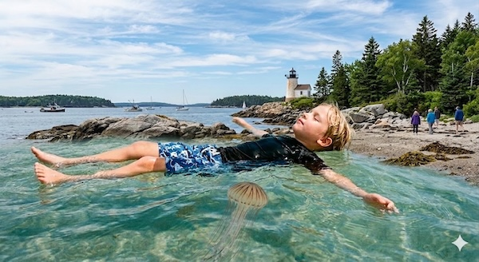
“Correction, Mr. Brown,” he said gravely. “I believe our troubles have just begun.”

