A First
Thanksgiving
When I first saw the sea
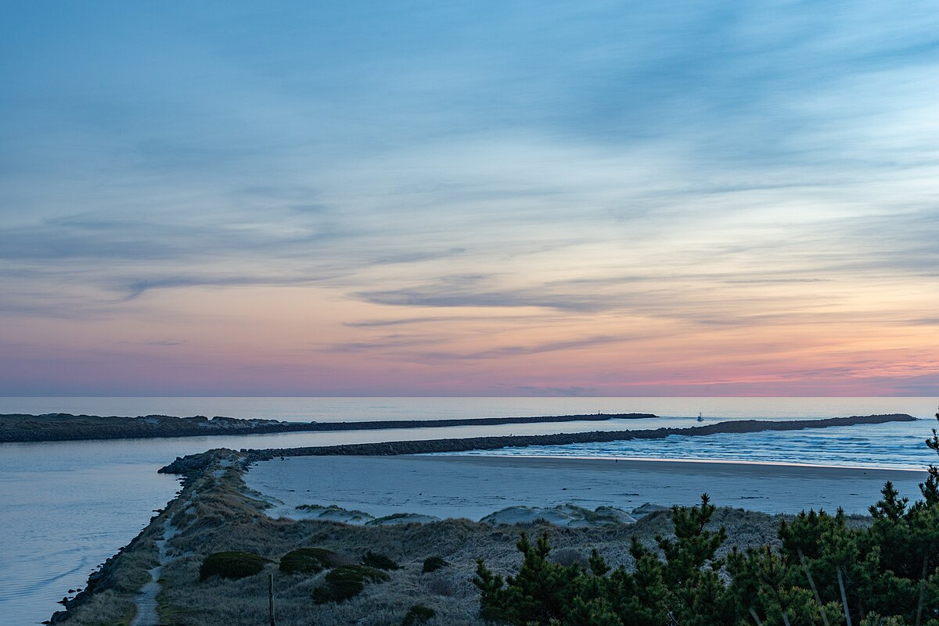

Douglas Evans

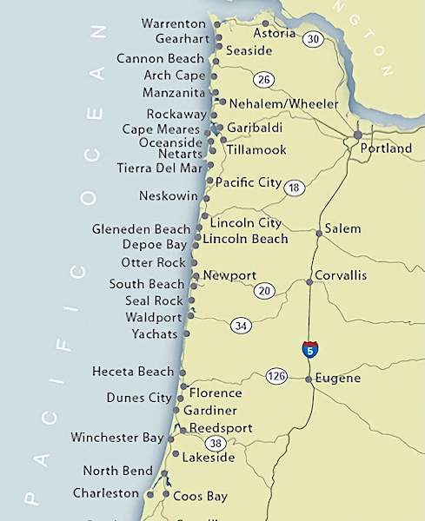

Parts

1. Corvallis, Oregon

2. Ocean Beach

3. Rain

4. Thanksgiving

5. Back to OSU

A short memoir of my first Thanksgiving away from home, when I hitch-hiked to the Oregon coast and saw the Pacific Ocean for the first time.

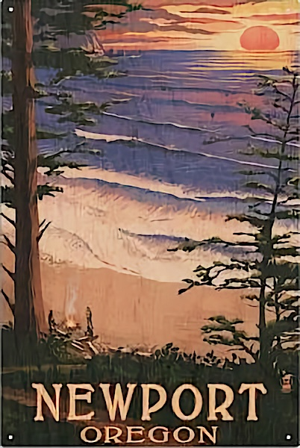

Part 1
Corvallis, Oregon

When I arrived in the fall of 1971, I knew very little about Oregon State University or the town of Corvallis, Oregon. I rode there by Greyhound bus from Edina, Minnesota, where I lived at the time. I didn’t even know how to pronounce the town’s name. I had chosen OSU simply because it was in Oregon, a state with forests, mountains, and beaches I wished to explore.
Since I enjoyed the outdoors, I first declared forestry as a major. However, after my initial class on wildlife control, where the professor’s lecture was about how to kill coyotes, I dropped the idea. For several years, I drifted as an out-of-state non-major. It wasn’t until my junior year that I made the fortunate decision to study education and become a grade-school teacher, a career that allowed me to spend my adult life working with children.
My freshman year dorm, Wilson Hall, was a sprawling three-building complex. But it closed over the Thanksgiving break. Unable to afford going home, I decided to hitchhike alone to Newport, Oregon, on the coast about sixty miles away. I had never seen an ocean. Now was the time.
Like most things about Oregon, I was clueless about the weather that time of year. Coming from Minnesota, I was used to the late November cold, but Oregon’s gray skies and endless drizzle were something else entirely. Constant rain, every day sunless and cloudy.
Hitchhiking in the ’70s was much more common and seemed relatively safe. I did it often. For that first trip to the coast, I made a sign that read BEACH and stood out on Highway 20, the road to Newport. I wore my yellow backpack and a poncho. I carried an old cotton sleeping bag and a large tent without a rainfly. For my Thanksgiving dinner, I brought a Cornish hen I planned to cook over a campfire. The weather was cold and rainy, but that didn’t bother me much. A little weather was nothing to worry about when I was eighteen
I don’t remember the first ride. But the Pacific Ocean called, and I was thrilled to be on my way to see it.

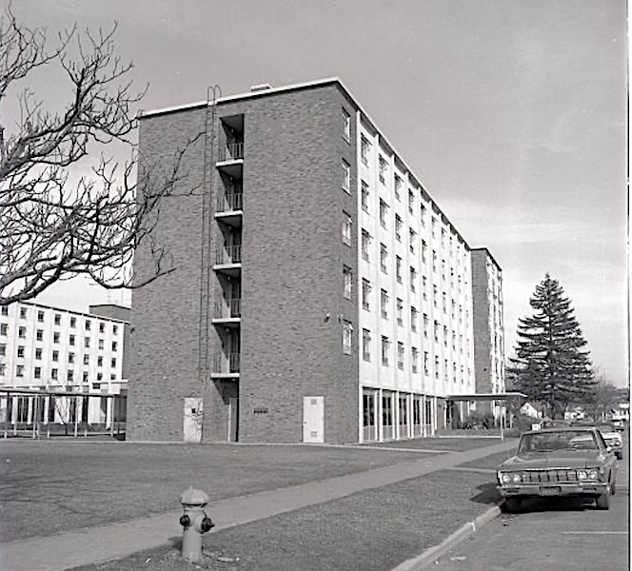

Part 2
Ocean Beach

I liked old town Newport right away. It was just how I imagined a small Pacific fishing town would be. It stood on the north shore of beautiful Yaquina Bay with the Yaquina River feeding into it. The green coastal mountain stood to the east and to the west, a long stone bridge carried Highway 101 across the water. Back then, old town Newport was far less touristy, and tin-sided fish canneries were still in operation. Along the single street stood fishing supply stores, taverns, and fish restaurants . On the wooden piers stood stacks of round crab pods, and fishermen were emptying their fishing trawlers with the day’s catches of salmon and Dungeness crabs. Down the road was a small sea aquarium, and across the bay stood the OSU Marine Science Center, which I hoped to visit over the weekend
Cormorants and fat seagulls perched on every wooden piling jutting from the water. I saw my first brown pelican and heard my first sea lion bark. Whiskered harbor seals—much larger than I had imagined—lounged on buoys floating just offshore.
The air smelled faintly of salt and fish. Everything was new and sensational. At last, I was spending a day at the ocean beach.
Hear my song Ocean Beaches on YouTube.
After exploring the waterfront, I splurged, despite my tight budget, and ate my first bowl of clam chowder at Moe’s, a small, well-known, open-air restaurant that I would return to many times on later visits.
Still, the rain fell. Beyond the bridge, toward the mouth of the Yaquina River, I heard the roar of the ocean, and that was where I headed next. I hiked up a steep road, passed the Coast-Guard Station, crossed Highway 101 at the start of the bridge, and entered a lovely park with picnic areas and ocean lookouts. Above me, the beam of a lighthouse shone westward across the gray water. Maybe this was the start of my interest in lighthouses around the world.
Then, standing in a small parking lot vista, I saw it, just beyond a sandy beach. The Pacific Ocean! I remember my first impression clearly. It was much louder and rougher than I ever imagined. Tall white breakers crashed close to shore. Mist filled the air, and fog covered the horizon. I could even feel the cliff vibrated as the waves pounded the sand
Nothing but water from here to Japan, I told myself. A third of the world is covered by this ocean.
To the south, two long walls of giant boulders lined both sides of the Yaquina River. They stretched far out to sea until they vanished in the fog. Together, they formed the wide entrance channel to Yaquina Bay. Several fishing trawlers were making their way home. Every few seconds, huge waves struck the northern wall and raced along it toward shore. Sometimes the breakers crashed over the top. Later, I learned these walls were called jetties. On later visits, I often climbed to the end of the north jetty, where I would sit and read all day.
A long wooden stairway took me down to the sandy beach. The sand was littered with clam shells, round stones, and sand dollars. I passed gnarly driftwood, heaps of rope-like bull kelp, and massive redwood logs good for sitting. How did these logs get so far up on the beach? Again, the power of the ocean amazed me.
In tide pools carved into slabs of basalt, I found multi-colored starfish, spiky sea urchin, sea anemone, clusters of mussels, a few small crabs, and crowds of barnacles. All a first. By-the-way sailor jellyfish also lay stranded on the sand beside dead fish that seagulls were tearing apart.
I searched for round Japanese fishing floats, which I had read sometimes washed ashore after drifting across the Pacific. (I’ve never found one.) Maybe I’d see a migrating gray whale? (Not this time) Maybe I’d see the sun set on the horizon for the first time. Or even a green flash! (Not this trip) I was enchanted. I dipped my Sierra camp cup into the water for a taste. Sure enough…salty.

Part 3
Rain

Despite the steady drizzle, I wanted to camp that night on the beach. But not only did a sign tell me it was illegal, but the ocean terrified me. The waves were far stronger and taller than I had pictured. And the tides. I knew a little about them, but I didn’t know how to read a tide table or how high the water might rise in the night. Would it cover the entire beach? So, instead, I decided to sleep in the park at the top of the stairs.
The sky had turned a dark, heavy gray, and the parking lot had emptied as I searched for shelter. Luckily, the picnic area offered open-sided structures with roofs, electric grills, and picnic tables. These would serve far better than my leaky tent. I picked a shelter tucked in back, where I would be less visible to passing rangers and police.
At last, out of the rain, I dropped my pack on the concrete floor and I checked the grill. A nickel bought half an hour of heat. Luckily, I had a few nickels in my pocket, and I spent one of the precious coins to warm my frozen hands above the glowing metal. By now the night was fully dark, the air much colder, and the wind was blowing hard off the ocean. The warmth and the soft glow from the grill lifted my spirits.
When I checked my pack, though, I found my sleeping bag and extra clothing soaked through. I used the final fifteen minutes of the five-cent grill heat to dry the bag as much as I could.
When the grill clicked off and its glow faded, the shelter plunged into eerie darkness. The only light came from a faint yellow bulb above the far-off restroom door. With the aid of my flashlight, I spread my sleeping mat and bag out on the picnic shelter floor. Then I pulled on my poncho, grabbed my toothbrush, and headed toward the yellow light.
To my relief, the men’s restroom was both clean and unlocked. I washed up and brushed my teeth, and enjoyed being out of the wind for a time.
Back in the shelter, I sat on a picnic table and stared into the night. The wind blew hard, and below the cliffs the ocean crashed. I had two nickels left, but I wanted to save them. Tomorrow was Thanksgiving, and every store would be closed. I had no idea where or when I could get more change for cooking and warmth. So I just sat there in the dark, alone.
I didn’t mind being alone. All my life, I preferred to travel and camp that way. By the age of eighteen, I had already camped solo in Minnesota many times, taken a trip to Yellowstone on my own, and paddled my canoe down several rivers without a companion. In the years to come, I would buy a VW van and spend every weekend camping alone around Oregon. Later, I would travel around the world several times by myself and visit more than a hundred countries solo. In Oregon and California, I always chose to live alone. A few good friends were enough for me.
But I remember that first night on the Oregon coast. I was alone, cold, and slightly frightened. No one in the world knew where I was. And the ocean below, with its endless tides and crashing breakers, were a mystery I hadn’t yet learned to trust.

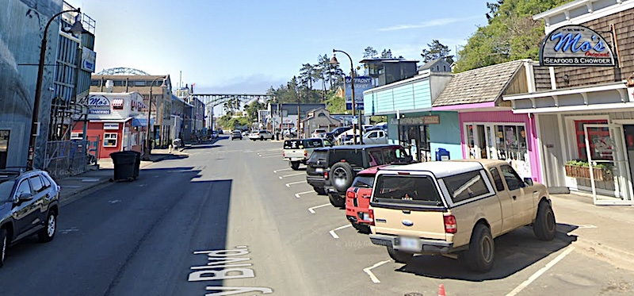

Part 4
Thanksgiving

That night was cold, perhaps in the upper 30s. Over fifty years later, I remember how I shivered in my damp sleeping bag. Hypothermia wasn’t yet in my vocabulary, but I knew if I didn’t warm up somehow, I’d be in trouble. Sometime during the night, I wriggled out of my wet bag and ran to the restroom, hoping that it would be warmer. The electric hand warmer helped a little.
Back in the windy shelter, I spent another nickel for a half-hour of grill heat and made some tea. Oh, bliss! My wind-up pocket watch read 3 AM. All I could do was to spend the rest of the night awake, sitting on the picnic table, keeping as warm as I could and listening to the crashing ocean.
Happy Thanksgiving. I sat there and watched the sky turn from black to dark gray. That’s how it often was in Oregon. My last nickel would serve double duty. It would warm my hands and boil water for breakfast.
Then an idea! All shops would be closed today, but not the gas stations. Highway 101, passing through the main drag of Newport, had many gas stations. Surely, some would be open on this busy tourist day. They all had little shops with snacks.
I packed up my damp gear and hid my pack in a clump of huckleberry bushes. In the dim morning light, I hiked up to 101. The road was covered in fog, and the bridge just down the road was hidden. The fog was so thick I couldn’t even make out the stores across the four-lane highway. But what luck. The first gas station I came to walking north was open with a well-lit shop.
I must have looked strange walking into the shop wearing a dipping green poncho by the attendant only said, “Happy Thanksgiving.”
I bought a pack of Oreo cookies, a quart of Mountain Dew, and a newspaper. I also broke a dollar bill for twenty nickels. After reading it, the newspaper would be used to start a fire in the picnic area fire pit to cook my Cornish hen.
This was long before cell phones. A phone booth stood near the gas station, but back then, calling long distance was very expensive, so I didn’t even think of calling my parents in Minnesota. I doubt they would have been too thrilled to hear I was camping alone on the rainy Oregon coast.
The weather remained wet, windy, and cold. Back in the park, the parking lot was still empty, and ,being Thanksgiving, there were no rangers or cleanup crews about. In the shelter, I boiled some water in my small cooking pot and made freeze-dried oatmeal for breakfast. Some crows and seagulls dropped by to watch.
Afterward, I explored the beach some more. The waves were calmer and quieter. They gently flowed up the sand and back again. Squads of small sandpipers raced back and forth with each wave. I could see they were eating the sand fleas that were hopping about the damp sand.
Not a footprint was in sight. That meant I was the first person on the sand that day. I found an agate and a whole sand dollar not pecked by seagulls. Surprisingly, the beach had totally changed from the day before. The driftwood was different, and there were more piles of bull kelp. Maybe the high tide did cover the entire beach last night.
Back in the ’70s, there were far fewer brown pelicans than there are today, but I saw a few glide by almost skimming the waves.
After my hike, it was time to build a fire and dry out my sleeping bag. I hunted in the wooded area for some dry kindling but found little. My spirits dropped after each attempt to build a fire failed. Even after burning most of the newspaper, no wood would catch. Everything was just too wet. If only the rain would stop and the sun would come out. But no, the sky remained a dark gray sheet.
In the early afternoon, the usual time for a Thanksgiving meal, I tried to build a fire again, but no good. How could I cook my Cornish hen. Over the grill? In boiling water? Nothing sounded plausible. So what did I do? Frustrated, I took the small hen down the stairs to the beach, and… I chucked it into the ocean. Good-bye bird. I hoped the seagulls would have a good feast.
My Thanksgiving dinner turned out to be Oreo cookies and Mountain Due. Afterward, I made the decision not to spend another freezing night in this dreary shelter and hitch-hike back to Corvallis. Enough was enough. So I packed my yellow backpack. Took one more look at the ocean and set off to the highway.

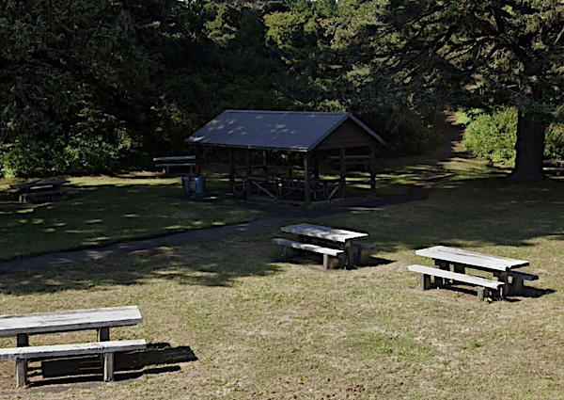

Part 5
Back to OSU

Thursday evening, Thanksgiving, I stood on the corner of Highway 101 and Highway 20 with a sign that read OSU, thankful for any ride I could get. I reached Corvallis after dark, in the rain. The only shelter I could think of was under the covered entrance to Wilson Hall. Another freezing night.
Before dawn, I hiked to Sambo’s, an all-night coffee shop with bottomless ten-cent coffee and a racist name. Over a tall stack of pancakes, I wondered about my next move. Maybe I could sneak into Wilson Hall and hole up in my dorm room for the weekend.
Luck struck. As I lingered outside Wilson, the cleaning ladies who knew me let me in. Adventure over! I spent the long weekend hidden in my dorm room, reading, until my roommate, Dan, returned Sunday afternoon.
***
So that was the first time I saw the sea. Of course, I returned to the Oregon Coast many times after that. Most weekends during college, I either hitch-hiked to the Cascade Mountains or to the beach. My girlfriend and I used a laminated sign that said Beach on one side and OSU on the other. We bought a crab ring and hauled it along, though I can’t remember what we ever did with the crabs we caught. What I do remember is eating clam chowder at Moe’s every single trip.
Just south of Newport was Seal Rock, a two-hundred-foot-tall basalt rock formation jutting out in the ocean. From Highway 100, its sides looked impossible to climb. But we discovered that if you scrambled around the northern side of the rock, the climb up the seaward side was surprisingly easy. At the top was a long soft mat of grass, sprinkled with wildflowers and birds nests. Those were the happiest times—lying in the grass, staring out at the Pacific. We often took a picnic up there and a dragon kite. During migration, many gray whales and their calves swam close by. One fall, we planted more than a hundred daffodil bulbs at the summit, and the following spring, we saw the yellow blooms from the beach below.
There was also the chip train. The tracks ran right past Wilson Hall, hauling car after car of wood chips to the paper mill outside Newport. At night, when the train slowed through Corvallis, my dorm-mates and I would grab a car ladder and climb onto the chips. We’d lie there for the two-hour ride to the coast.
Once in Newport, we killed time in a coffee shop, waiting for the train back to Corvallis. This was trickier. The cars were now empty, so we had to climb up the outside ladder and down into the hollow bin. Railroad bulls with flashlights prowled the yard. If we saw their beams, we froze, making sure we weren’t standing in a crack where the light would expose us.
I wonder if Wilson students still ride the rails to the beach today.
Hear my song Pacific Ocean, It Has 3 C’s on YouTube!
Hear my song Ocean Beaches on YouTube!
