


Serialized

Chapter Three
The Sandman
Bug One stood. He removed his spectacles, puffed on each lens, polished them against his shell, and pinched them back on his nose. After clearing his throat twice, he began his story like this:
“Madam, most children have heard of the Sandman. But few know how he goes about his nightly business, and even fewer know where he comes from. Well, let me tell you, the Sandman lives in a grand sand castle on a silver sandy beach in the Sandwich Islands.”
Irene blinked. She scrunched down to get snugger, careful not to topple the three bedbugs on top of her.
Bug One went on. “Each night when the frogs begin to croak, the Sandman grabs his silver bucket and scoops up some sand. This is no ordinary sand, mind you, but silver-sleeping sand that is invisible by sunlight yet glitters in the moonlight. With the bucketful of this sand in hand, the Sandman whisks off at the speed of light to visit every girl and boy in the world who has just climbed into bed.”
Irene shook her head. “But that’s
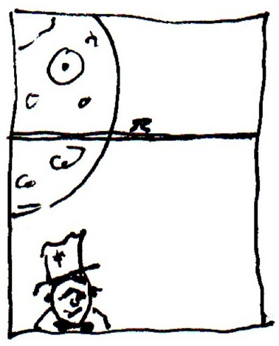
impossible, little bug. How could the Sandman be at so many beds at the same time?” “Hoo! Hoo! That’s precisely the reason children have different bedtimes, madam,” the fat bug said.
“So have you seen the Sandman in my bedroom?”
Bug One beckoned toward the moonlit window. “Each and every night, the silver-haired fellow with silver freckles crouches on your front lawn, waiting for you to close your eyes. Everything he wears, from his silver trousers and silver swallowtail jacket to his silver top hat and silver dancing shoes, blends in with the light of the moon. The moment your eyelids come down, even before they shut completely, he leaps through the windowpane and dances to your bedside. From there, he sprinkles a pinch of sleeping sand in the four corners of your eyes.”
“Truthfully?” Irene whispered.
Bug Two stood, waving four arms. “A bedbug cannot tell a lie,” he reminded her. “The Sandman is a clever fellow, my dear. But how clumsy and careless he can be. The bedbugs must make sure your eyes get the proper dose of sand, not a grain too much or a grain too little. Too much and you would sleep through breakfast. Too little and you would wake in the middle of the night.”
“And what if one eye received more sand than the other?” Irene had to ask.
Bug Three, stroking his black beard, answered this. “You would be half-asleep at
school the next day. And teachers don’t like that one bit.”
“I should say,” said Irene, with a knowing nod.
“But the nastiest nights, madam, the worst of all, are when the Sandman is late,” said Bug One. “And last Sunday was one of his tardy nights. Hoo! Hoo!”
“Sunday?” said Irene. “Wasn’t that the night I lay awake tossing and turning for the longest time?”
The fat bug nodded. “Four times you left the bed for a drink of water; three times you rose to go to the toilet.”
“So tell me, bedbugs,” said Irene. “What happened when the Sandman finally arrived?”
“A catastrophe!” Bug One said gravely.
“A catastrophe!” said the other two.
“A catastrophe?” said Irene. “Mercy me.”
(Listen The Sandman song)


