
Serialized
5
Secret Sleeping Spots
Every pigeon has a secret sleeping spot. It might be a hole in a post, a crevice in a wall, or a crack in a chimney. Some pigeons sleep above windowsills, under bridges, or on ledges of tall skyscrapers. Wherever the place, it’s well hidden, and that’s why people rarely see pigeons at night. The birds have all gone off to their secret sleeping spots.
The sun had disappeared behind the intersection of College and Ashby. College students with laptops filled the Café Roma. Evening joggers passed on the sidewalk, and buses carried people home from work.
A cool breeze ruffled Del’s feathers as he viewed the evening from his streetlight perch. Recently, he had found a sleeping spot that he thought was ideal. The day before, scaffolding had been erected against the front wall of the library. One scaffolding pipe near the top fit him perfectly. It was snug and warm and high enough off the ground to offer protection against predators.
“My neeew tuuube is the best pigeon hole in the neighborhoood,” Del told himself. “It’s so well hidden, no one will ever know about it but me.”
As the evening skies darkened, Estelle also remained on her streetlight. She pecked a grain of sand from a wing and looked toward Del’s corner.
“Del’s so proud of that noisy pipe he sleeps in,” she said. “Too bad that once the library is painted, the scaffolding will be removed and he will be homeless again.”
Estelle peered longingly at a rhododendron bush in the back of Wells Fargo Bank. She had called the leafy plant home for the past year. A fork in its trunk made the ideal secret sleeping spot, cozy, sturdy, and out of sight. An hour ago, she would have retreated to her bush hadn’t Del’s been acting so peculiar.
“Coo-a-roo! Del never stays up this late,” she said. “And he’s been watching my streetlight like a turkey vulture. What’s he up to? Could he be wondering where I roost at night? Foolish coot. I bet he’s worried that my sleeping spot might be better than his cold pipe.”
At this point, the streetlights along College and Ashby came on. Del walked to the edge of his light. An amber glow lit up his dark face.
“Your sleeping spot couldn’t be better than my tuuube, Estelle,” he said in his head. “And tooonight, I’ll prooove it. Tooonight I’ll follow yooou and see where yooou sleep.” He shifted from foot to foot. “Coo! Hot foot! Hot foot! The light is getting toasty. Come on, Estelle, get moooving! Hot foot!”
Meanwhile, Estelle faced Elmwood Movie Theater. “It’s time to move,” she said. “But my cozy bush will have to wait. I must find out what Del’s up to.”
Silently, she soared from her perch. A short time later, a loud clatter of wings sounded from the direction of Del’s streetlight. Estelle flew a half-block up College Avenue and landed on the movie theater’s marquee, brightly lit at this time of night. Below her, a line of people stood at the ticket booth out front. Above, she heard Del land on the gutter.
“Just as I thought,” she said. “That goony bird is following me. Well, Del, if you want to play a game tonight, let’s play one Wild Goose Chase.”
Del leaned forward to spy on Estelle. “Hoo! Hoo!” he said. “Stealthy Del is on your tail, Estelle. Yooou won’t hear a sound from this shreeewd pigeon. This should be amuuusing.”
He watched Estelle fly off the marquee and glide across College Avenue. When she disappeared over the College Avenue Bookstore, he took off after her. He nearly ran into a power line before rising over the bookstore roof. There, he spotted Estelle turn northward down Cherry Street.
“Woohoo,” he said. “The pursuuuit is on. But I can’t let Estelle get tooo far ahead, or I’ll looose her.”
Winging up Cherry Street, Estelle slowed her pace. “If I don’t slow down, Del will lose me,” she said. “Pokey pigeon. You really should be in better shape, Del.”
When she heard Del’s clapping wing again, Estelle cut eastward up a driveway. By now, night had fallen, and stars twinkled in the purple sky.
“Coo-a-roo! Night flights are so pleasant,” she said. “I hope Del is enjoying this as much as I am.”
Meanwhile a block behind Estelle, Del was flying low to the ground. “Oooo, I’m poooped,
and my wings ache!” he said.
He followed Estelle up the driveway and over a housetop. He flew through a backyard, over a tall fence, down another driveway, across a street, and into a vacant lot.
“Why’d yooou chooose a sleeping spot so far from our intersection, Estelle?” he griped. “Oooo! I should leave night flying to the gooofy owls.”
A hundred yards ahead, Estelle turned eastward and flew across a supermarket parking lot. She landed upon a mailbox and waited for Del to catch up.
“I hear Del’s wing beat slowing down,” she said. “Time to end this Wild Goose Chase.”
Shortly after Estelle left the mailbox, Del landed on the same spot. “Where am I? I’m lost!” he said. He caught sight of Estelle flying up a side street. “Estelle, this is yooour fault. Coo! How can I find my way back to my pigeonhole pipe? Estelle! Don’t get tooo far ahead. Coo! Coo! Wait up, Estelle!”
Del took off down the street. Two blocks later, he spotted Estelle standing on the sidewalk in the glow of a streetlight. He recognized the sidewalk, and he recognized the building behind it. He landed on a familiar fire hydrant.
“Coo! That’s the library, and there’s the scaffolding. And Estelle is standing right below my… Coo!”
With a final flap of his wings, Del flew toward the grid of pipes and planks erected against the front of the library. He landed on the lead pipe that served as his new secret sleeping spot.
While Del backed into the pipe, Estelle spread her checkered wings. Without turning her head, she glided into the shadows.
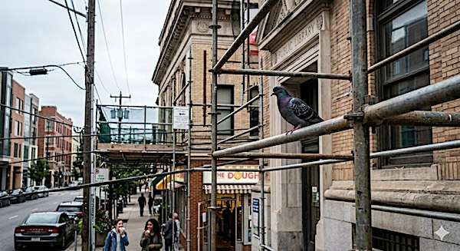
“Yes, Del is no homing pigeon,” she said.

